Image Classifier: Real or Fake (AI) Final Report
In recent years, with the rise of generative Artificial Intelligence, more content are being created that originated from these generative AI models such as Chat-GPT, DALL-E, Veo, etc. While this opens the door to many more people to pursue content generation and verification, whether it is for marketing, learning, or simply for entertainment, this also comes at the cost of controversy surrounding ethics, trust, security, and commercialization. What if the difference between a real image versus an AI generated one becomes crucial.
For a tech startup with an emphasis on computer vision, multiple clients have approached us asking for some variant of a computer model that can classify different types of images into whether they are real (taken by a person/camera), or fake (generated by AI). Though each client’s request is regarding images from completely different categories, ranging from face IDs all the way to evidence at a crime scene, they all share the fundamental problem of differentiating between real and fake images.
With the background and problem established, now came determining the best solution. Dealing with images meant requiring a model that uses deep learning via neural networks. However, neural networks can be expensive to build, train, and maintain both in terms of cost and time.
Fortunately, instead of constructing a neural network model for each client, only one base model is needed. This is thanks to transfer learning. Essentially, transfer learning allows an existing neural network model already built and trained on, for example, an image recognition dataset of animals, to be adjusted and modified so it can also perform similar image recognition or classification problems without having to rebuild the model from the ground up. This eliminates the building time dramatically and significantly reduces the training time needed.
In short, the objective is to build a base model around a generalized set of images. This way for each specific client, transfer learning is done on the base to then create each specialized model. This report will cover the base model process.

The Data Science Method
An existing image dataset was found to contain 60,000 images. The images are split between a train and a test folder in a 4:1 ratio respectively. In each folder, the images evenly divided into real and fake (AI) image folders.
In terms of data wrangling, all the images were in .jpg or .png, meaning no further cleaning was necessary. What was an issue was the dataset size. Images take up much more memory than tabular data, thus 60,000 images was going to be a heavy strain on the computer just to load all of them into the code. It clearly was not feasible to pipe in these images into the models for training, so they all needed to be downsized. Two downsized variants were produced, 128x128 pixels, and 224x224 pixels, any misfitted images were padded with black pixels.
The images then had to be stored in the proper file path to ensure easy model training. This is done by re-ordering the pathing of all the downsized images. From a new folder called modified_data:
- modified_data
  - train_128
    - fake
    - real
  - test_128
    - fake
    - real
  - train_224
    - fake
    - real
  - test_224
    - fake
    - real
The images within each train and test subfolder were also shuffled when loaded into the program. This way the file path follows that of the original data organization.

For the modeling phase, five candidate neural networks were evaluated. Two were constructed from scratch, the remaining three were imported. All models were experimented on within the tensorflow.keras package.
The models were as follows:
- Convolutional neural network (128x128 images)
  - A convolutional neural network (CNN) built from scratch to be trained with the 128x128 images. Network consisted of 8 layers including convolution, pooling, flatten, dropout, and dense.
- Convolutional neural network (224x224 images)
  - A CNN built from scratch to be trained with the 224x224 images. Network consisted of 8 layers of the same types as the previous model.
- ResNet-50 (Residual Network)
  - A CNN imported from tensorflow.keras.applications.resnet50 to be trained with the 224x224 images. Network had 107 layers and included those listed above as well as skip connections, where layers of little use or detriment would be skipped over during training.
- EfficientNetV2-B0
  - A CNN imported from tensorflow.keras.applications to be trained with the 224x224 images. Network had 132 layers. Uses compound scaling to uniformly scale each dimension with a fixed set of coefficients instead of randomly scaling the dimensions.
- ConvNeXtBase
  - A CNN mixed with elements from Vision Transformers (ViT), a type of large vision models. Large vision models are a counterpart to large language models like ChatGPT. Trained on 224x224 images. Vision Transformers process images as sequences of patches and use self-attention, leading to greater accuracy and flexibility.
For the three models that were imported and trained with transfer learning, all their deep layers were frozen and then custom heads were attached to the end as an adjustment to the classification task for this analysis. The heads included GlobalAveragePooling, Flatten, Dropout, Flatten, and output layers.
The two models that were selected were ResNet and ConvNeXtBase, as both performed with strong accuracies. Note, ResNet will be recommended to be the primarly base model as it is much cheaper to run in terms of computing power. ConvNeXtBase has a slightly higher accuracy than ResNet but requires a strong GPU to train it in an acceptable timeframe. If the computer system the base models are being run on is strong enough, then ConvNeXtBase becomes the preferred model of choice. In addition, ConvNeXtBase is essentially an innovation from ResNet, as it got its CNN structure from ResNet.

Below are multiple graphs depicting the performance of each models regarding accuracy, overfitting, and runtime.
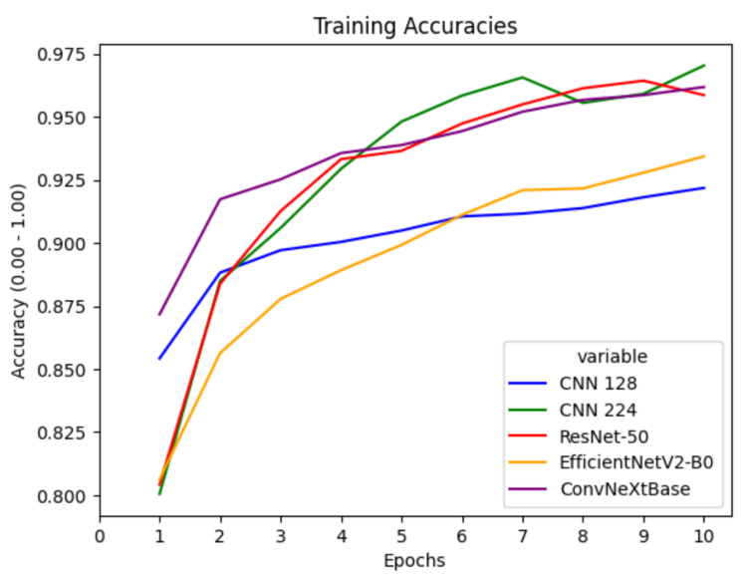

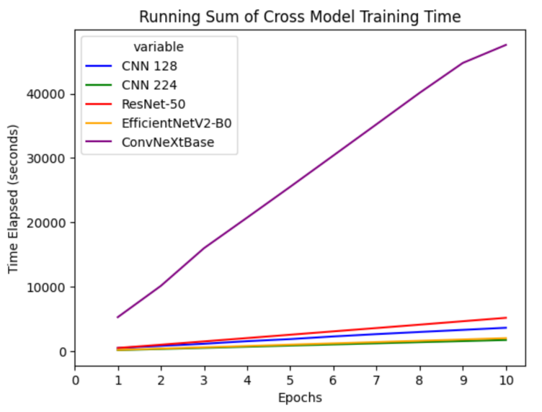
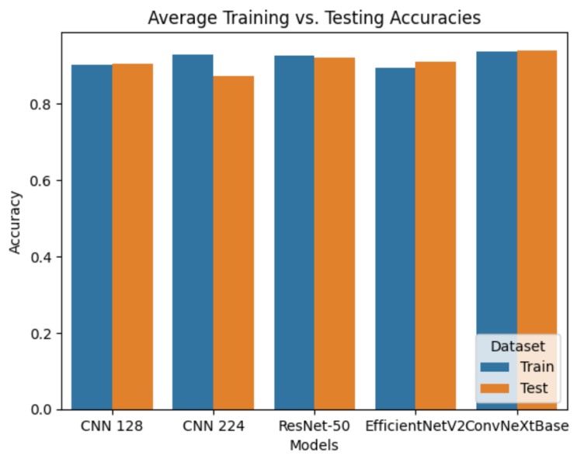
Comparison of training accuracies across all candidate models. CNN 224 and EfficientNet trailed the other three after 10 epochs.

Comparison between each models’ training vs testing accuracies. CNN 224 shows significant overfitting while all other models less so.

A graph depicting the cumulative time spent for training across each model. ConvNeXt sees its training time to be many magnitudes greater than any of the other models.

As seen in the third graph, although ConvNeXt has by far the longest runtime, all the models were trained under the same conditions in training dataset size, epoch count, and no use of the GPU to speed up the process. If the GPU was factored in to assist in the training time, the ConvNeXt model training time would be greatly reduced.
ConvNeXt’s CNN base architecture coming from ResNet also sets it up nicely as a successor to ResNet for any computer system that chose initially ResNet for its lower computation cost but then has or got upgraded with a stronger GPU can smoothly switch to ConvNeXt.
ConvNeXt also being integrated with Vision Transformers demonstrates a potential future path for deep learning models. Vision Transformers are a type of large vision models, essentially the counterpart to large language models that include ChatGPT, Copilot, and Gemini. As stated and shown above, LVMs use up much more computation power, but can generate much more accurate results. Potential future models can lean more into LVMs to strive for greater accuracy as the computation power of computers improve and innovation will allow LVMs to become more efficient in runtime.
Conclusion: Use ResNet as a default. If the computer system has enough GPU computation power, use ConvNeXt for its greater accuracy and potential for further improvements in future models that lean into LVMs.

